TREE DATA STRUCTURES (DEEP DIVE)
explained from fundamentals → interview-advanced, pure Java, NO Collection Framework,
with binary tree, BST, traversals, problems, and dry-run thinking.


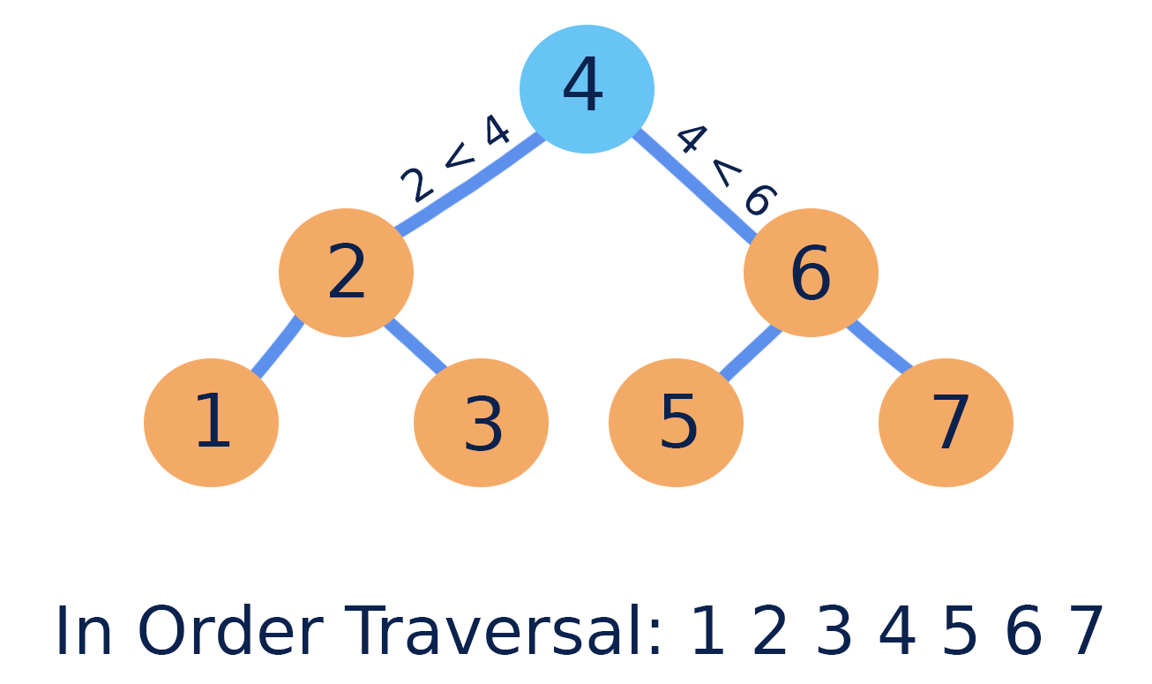

MODULE 9 – TREE DATA STRUCTURES

1. What is a Tree
- Tree is a non-linear data structure
- Organizes data hierarchically
- Consists of nodes connected by edges
Meaning
Tree represents parent–child relationships efficiently.

2. Why Tree is Needed
- Faster search than array/linked list
- Represents hierarchy naturally
- Used in databases, file systems, compilers

3. Tree Terminology (INTERVIEW MUST)
- Node → data element
- Root → topmost node
- Parent / Child
- Leaf → node with no children
- Height → longest path from node to leaf
- Depth → distance from root
- Level → depth + 1
A
B C
D E F G

4. Types of Trees
- Binary Tree
- Binary Search Tree (BST)
- Heap
- AVL / Red-Black (advanced)

🔹 BINARY TREE

5. Binary Tree Definition
- Each node has at most 2 children
- Children are:
  - Left
  - Right

Node Structure
class Node {
int data;
Node left;
Node right;

Node(int data) {
this.data = data;
left = right = null;
}
}

Create a Binary Tree (Manual)
Node root = new Node(1);
root.left = new Node(2);
root.right = new Node(3);
root.left.left = new Node(4);
root.left.right = new Node(5);

5
4 3
1 2

CEO
Manager1 Manager2 HR

Developer1 Devloper2 Tester

8. Tree Traversals (VERY IMPORTANT)

Inorder (Left → Root → Right)
void inorder(Node root) {
if (root == null) return;
inorder(root.left);
System.out.print(root.data + " ");
inorder(root.right);
}

Preorder (Root → Left → Right)
void preorder(Node root) {
if (root == null) return;
System.out.print(root.data + " ");
preorder(root.left);
preorder(root.right);
}

Postorder (Left → Right → Root)
void postorder(Node root) {
if (root == null) return;
postorder(root.left);
postorder(root.right);
System.out.print(root.data + " ");
}

9. Traversal Use Cases
- Inorder → sorted output (BST)
- Preorder → tree copy / serialization
- Postorder → delete tree

10. Height of Tree
int height(Node root) {
if (root == null) return -1;
return 1 + Math.max(height(root.left), height(root.right));
}

11. Count Nodes
int countNodes(Node root) {
if (root == null) return 0;
return 1 + countNodes(root.left) + countNodes(root.right);
}

12. Count Leaf Nodes
int countLeaves(Node root) {
if (root == null) return 0;
if (root.left == null && root.right == null) return 1;
return countLeaves(root.left) + countLeaves(root.right);
}

BINARY SEARCH TREE (BST)

13. BST Definition
- Left subtree < Root
- Right subtree > Root
- No duplicates (assumption)
Meaning
BST enables fast searching.

14. Insert in BST
Node insert(Node root, int key) {
if (root == null) return new Node(key);

if (key < root.data)
root.left = insert(root.left, key);
else if (key > root.data)
root.right = insert(root.right, key);
return root;
}

15. Search in BST
boolean search(Node root, int key) {
if (root == null) return false;
if (root.data == key) return true;
if (key < root.data)
return search(root.left, key);
else
return search(root.right, key);
}

16. Minimum & Maximum in BST
int minValue(Node root) {
while (root.left != null)
root = root.left;
return root.data;
}
int maxValue(Node root) {
while (root.right != null)
root = root.right;
return root.data;
}

17. Delete Node in BST (INTERVIEW FAVORITE)
Cases:
- Leaf node
- One child
- Two children

Node delete(Node root, int key) {
if (root == null) return root;
if (key < root.data)
root.left = delete(root.left, key);
else if (key > root.data)
root.right = delete(root.right, key);
else {
if (root.left == null)
return root.right;
else if (root.right == null)
return root.left;
root.data = minValue(root.right);
root.right = delete(root.right, root.data);
}
return root;
}

18. BST Inorder Gives Sorted Order
inorder(root); // sorted output

🔹 ADVANCED TREE PROBLEMS

19. Lowest Common Ancestor (BST)
Node lca(Node root, int n1, int n2) {
if (root == null) return null;

if (root.data > n1 && root.data > n2)
return lca(root.left, n1, n2);

if (root.data < n1 && root.data < n2)
return lca(root.right, n1, n2);

return root;
}

20. Check if Tree is BST
boolean isBST(Node root, int min, int max) {
if (root == null) return true;

if (root.data <= min || root.data >= max) return false;

return isBST(root.left, min, root.data) &&
isBST(root.right, root.data, max);
}

21. Mirror of Binary Tree
void mirror(Node root) {
if (root == null) return;

Node temp = root.left;
root.left = root.right;
root.right = temp;

mirror(root.left);
mirror(root.right);
}

22. Time Complexity Summary
- Traversal → O(n)
- Search (BST avg) → O(log n)
- Search (BST worst) → O(n)

23. Real-Time Use Cases
- File systems
- Database indexing
- Compiler syntax tree
- Expression evaluation

24. Common Interview Questions
- Difference between binary tree & BST
- Tree traversal orders
- Delete node in BST
- Height vs depth
- Balanced vs unbalanced tree

ONE-LINE INTERVIEW SUMMARY
Tree is a hierarchical data structure where binary trees and BSTs enable efficient searching, insertion, and traversal operations.

